Focus Group for App Design

|  |  |  |  |
| --- | --- | --- | --- |
|  | App Design1(Marvel) | App Design 2 ( | App Design 3 |
| Overall Design | 7 | 8 | 8 |
| User Experience | 7 | 7 | 7 |
| Ease of use | 6 | 7 | 6 |
| Usefulness | 7 | 7 | 7 |

App 1

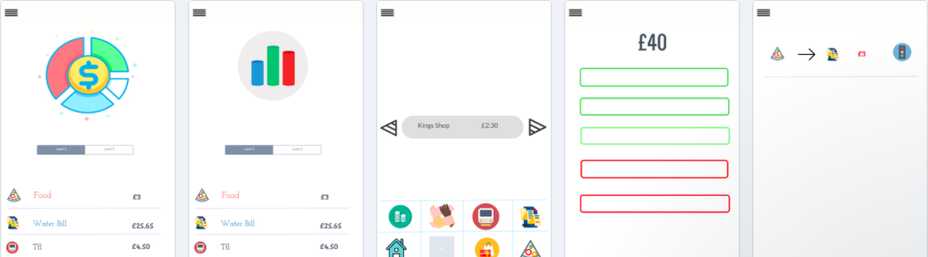

App 2

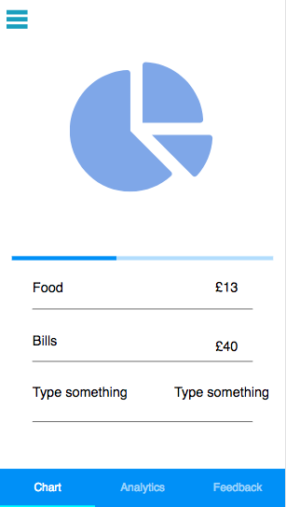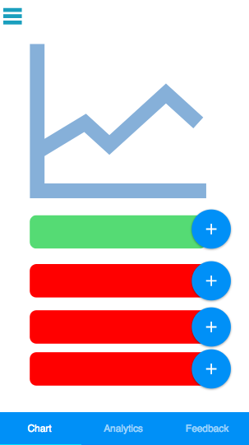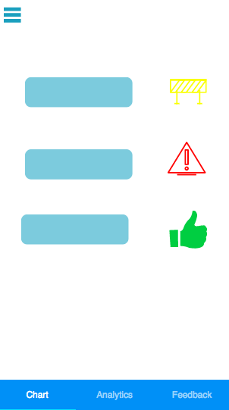

App 3

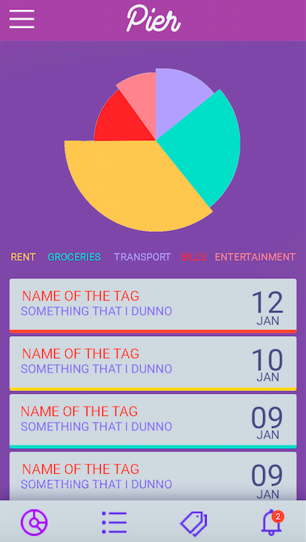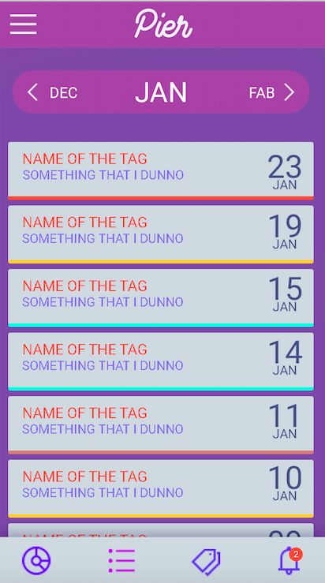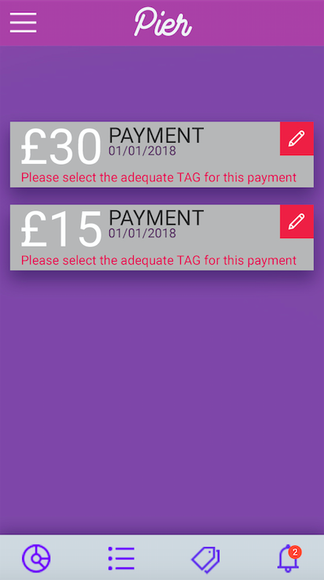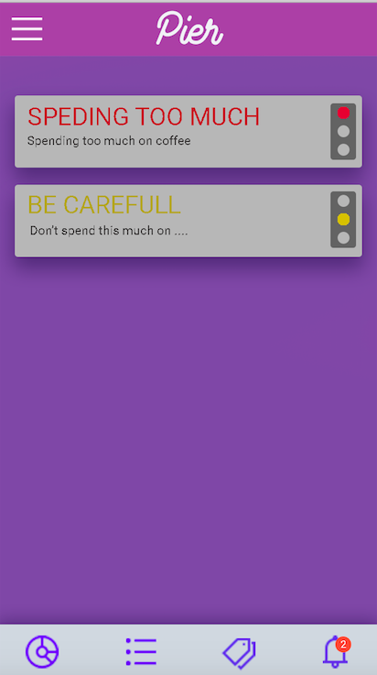

For Each function

**Breakdown –**

Which App has the best breakdown?

App 3

What would you change/add to make it better in your opinion?

Tag size

**Data Analytics -**

Which App has the best breakdown?

App 3

What would you change/add to make it better in your opinion?

- more white space needed

**Tags-**

Which App has the best breakdown?

App 1

What would you change/add to make it better in your opinion?

Multiple

**Alerts**

Which App has the best breakdown?

Traffic- app1

What would you change/add to make it better in your opinion?

**Input Method**

Method 1 – Leave to side bar- 3

Method 2 – Put in tab

Any other comments/ Suggestions